DESIGN SUMMARY
This study presents the process design and engineering analysis of an industrial-scale bioethanol production facility based on dry-milling corn feedstock, with a target output capacity of 100,000 L/day (33,000,000 L/year based on 330 operational days per year). The overall process encompasses four sequentially integrated unit operations: mechanical size reduction by hammer milling, enzymatic hydrolysis (liquefaction and saccharification), anaerobic fermentation, and continuous fractional distillation.
Raw corn is supplied at a wet mass flow rate of 12,170 kg/h, containing 14% moisture and 71% starch on a dry basis. The hammer mill reduces kernel size from F80 = 5,000 µm to P80 = 400 µm at a calculated net shaft power of 37.1 kW. The resulting corn flour slurry undergoes two-stage enzymatic hydrolysis in a 276 m³ continuous stirred tank reactor (CSTR) with a 6-hour hydraulic retention time and a 138 kW agitator motor. A starch-to-glucose conversion efficiency of 95% is applied. Anaerobic fermentation is carried out by Saccharomyces cerevisiae in four parallel bioreactors, each with a geometric volume of 552 m³, based on a 48-hour residence time and a 90% glucose-to-ethanol conversion yield. The total exothermic heat load generated during fermentation is 3,525 kW, which must be continuously removed via external cooling jackets to maintain the optimal yeast operating temperature of 30–32°C.
The dilute fermentation broth (8.06 wt% ethanol, xF = 0.0332) is fed as a saturated liquid (q = 1.0) to a continuous sieve-tray distillation column designed using the McCabe-Thiele graphical method with ethanol-water vapor-liquid equilibrium (VLE) data at 1 atm. Based on the overall material balance, the feed, distillate, and bottoms flow rates were calculated as 2,123.2 kmol/h, 77.88 kmol/h, and 2,045.3 kmol/h, respectively.The minimum reflux ratio was determined as Rmin = 3.40, and the operating reflux ratio was set at R = 4.42 (1.3 × Rmin). The McCabe-Thiele step-off procedure yielded 15 theoretical stages (including the reboiler), corresponding to 14 ideal stages within the column shell. Applying an overall Murphree tray efficiency of 70%, the number of actual physical sieve trays was calculated as 20, with the optimal feed tray identified at stage 7 from the top.
Column hydraulic sizing was conducted separately for the rectifying (top) and stripping (bottom) sections using the Souders-Brown flooding velocity correlation with an 80% safety factor. The top section vapor and liquid mass flow rates were calculated as 18,201 kg/h and 14,843 kg/h, respectively, yielding a liquid-vapor flow factor (FLV) of 0.0352 and a flooding velocity of 2.084 m/s. The resulting operating vapor velocity is 1.667 m/s, leading to a net column cross-sectional area of 2.022 m² and a total cross-sectional area of 2.29 m². The final design column diameter, rounded up to the nearest standard commercial size, is 1.80 m. The total column shell height, including 0.5 m tray spacing, 1.5 m top vapor disengagement space, and 2.0 m bottom sump, is 13.0 m. The distillate product purity is 95.6 wt% ethanol (xD = 0.8948), and ethanol loss in the bottom wastewater stream is restricted to 0.1 wt% (xB = 0.000391).
The economic evaluation was conducted through a factored capital cost estimation method. The total purchase cost of core equipment (distillation column, hydrolysis tank, and four fermentation vessels) is 4,737,339 TL. Applying standard Material Module Factor (MMF = 0.71) and Labor Module Factor (LMF = 0.42), the total Grassroots Capital (Cgr) was estimated at 23,744,741 TL, and the Total Capital Cost including 15% working capital reserve amounts to 27,306,452 TL. The facility is designed for long-term continuous operation, contributing to the domestic renewable fuel supply chain and offering a competitive production cost structure relative to fossil-based fuel alternatives.

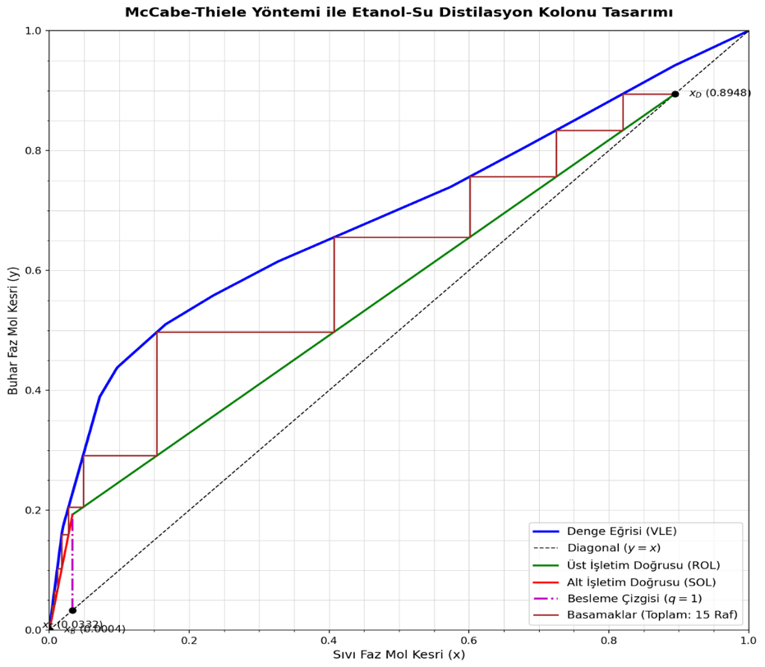
McCabe-Thiele Diagram for Distillation Column Desing

